



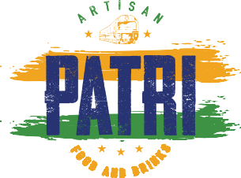





PARTY MENU
Silver Menu
Course 1 - Street Food
Pani Puri Shots Vegan Boyfriend Chaat

Course 2 - Grills
Paneer Tikka Chicken Malai Tikka

Course 3 - Curry
Daal Makhani Masala Vegetable of the Day
Chicken Tikka Makhani Chef's Special Lamb Keema Curry

Sides
Steamed Rice Naan Baskets Dessert of the Day
£ 32.95
Per Person Excluding Service Charge
PLATINUM Menu Food
Course 1 - Street Food
Pani Puri Shots Vegan Boyfriend Chaat
Aloo Tikki Chaat The Engagement Chaat

Course 2 Grills
Tandoori Brocolli Paneer Tikka Chicken Malai Tikka Lamb Seekh Kebab

Course 3 - Curry
Daal Makhani Paneer Makhani
Masala Veg of the Day Chicken Tikka Makhani Tender Lamb Curry
Chef's Special Sea Food Moilee

Sides
Pilau Rice Naan Baskets
Dessert of the Day
£ 45.95
Per Person Excluding Service Charge
SAFETY PRECAUTIONS
- Please carry a valid EpiPen at all times during your visit for safety
- Complete Allergen Menu is available on our website
- We do not allow any outside
cakes or desserts at any time
2026
gold Menu
Course 1 - Street Food
Pani Puri Shots Vegan Boyfriend Chaat
Aloo Tikki Chaat

Course 2 Grills
Paneer Tikka Chicken Malai Tikka Lamb Seekh Kebab

Course 3 - Curry
Daal Makhani Paneer Makhani
Chicken Tikka Makhani Tender Lamb Curry

Sides
Pilau Rice Naan Baskets
Dessert of the Day
£ 38.95
Per Person Excluding Service Charge
ALLERGEN STATEMENT
- We are unable to cater for serious allergies during Party Events.
- Menu items may come in contact with Soya,Wheat,Sesame Nuts, Eggs, Peanuts and Milk
- Our kitchen uses a common fryer and tandoor so we cannot guarantee 100%
Gluten Free dishes.
VEGAN/VEGETARIAN CURRY SUBSTITUTES
Masala Aubergine Kale Pakora Moilee Paneer Makhani

